|  |
| --- |
| Project PAM |
| Project PAM  A Reference Design for  Photoresin Additive Manufacturing  for the  Saluki Makerspace  Saluki Engineering Company  Reference Number: S14-75-3DPR  Chance Baker (EE)  Jeffrey Burdick (ME)  Nicholas Lowman (CE)  Daniel Olsen (CE)  Casey Spencer (EE) |

2014-04-18

Saluki Engineering Company

Southern Illinois University Carbondale

College of Engineering – Mail Code 6603

1230 Lincoln Drive

Carbondale, IL 62901

Steven Blair, President

Saluki Makerspace

Southern Illinois University Carbondale

College of Engineering – Mail Code 6603

Room E0021

1230 Lincoln Drive

Carbondale, IL 62901

Mr. Blair,

On behalf of the Saluki Engineering Company, I would like to thank you for including us in the bid for a project to design a digital light processing printer. Attached is our proposal, Project PAM, project number S14-75-3DPR.

Project PAM proposes a reference Photoresin Additive Manufacturing (PAM) system which maximizes accessibility to the hobbyist. It is intended to be flexible by allowing for configurations of hardware available or easily obtainable to the end user. This is achieved through extensive use of currently available or easily fabricated hardware and open-source software. The reference design will be open-source hardware and software to the lowest practical level. Thorough documentation will provide the necessary means for the end user to go from an empty table to a functioning printer.

Please feel free to contact me at (815) 214 9661 or by email, [burdickjp@siu.edu](mailto:burdickjp@siu.edu), if you have questions about this project.

Jeffrey P Burdick

Project Manager, Project PAM

Saluki Engineering Company

# Executive Summary: Project PAM

With the increasing demand for a high precision desktop three-dimensional printer, the use of digital light processing (DLP) printing is growing. Currently, this technology is not easily accessible to the hobbyist or open-source community. Existing DLP printers are costly and are not within the budget of the hobbyist.

Project PAM proposes a reference Photoresin Additive Manufacturing (PAM) system which maximizes accessibility to the hobbyist. It is intended to be flexible by allowing for configurations of hardware available or easily obtainable to the end user. This is achieved through extensive use of currently available or easily fabricated hardware and open-source software. The reference design will be open-source hardware and software to the lowest practical level. Thorough documentation will provide the necessary means for the end user to go from an empty table to a functioning printer.

The project will be completed in three phases: build phase, testing phase, and presentation phase. The build phase is expected to be completed by September 26, 2014, allowing for several weeks of testing and tuning before the demonstration during the week of December 1, 2014. The total cost of the project is not expected to exceed $1000.00.

# RESTRICTION ON DISCLOSURE OF INFORMATION

The information provided in or for this proposal is the confidential, proprietary property of the Saluki Engineering Company of Carbondale, Illinois, USA. Such information may be used solely by the party to whom the proposal has been submitted by the Saluki Engineering Company and solely for the purpose of evaluating this proposal. The submittal of this proposal confers no right in, or license to use, or right to disclose to others for any purpose, the subject matter, or such information or data, nor confers the right to reproduce or offer such information for sale. All drawings, specifications, and other writings supplied with this proposal are to be returned to Saluki Engineering Company promptly upon request. The use of this information, other than for evaluating this proposal, is subject to the terms of agreement under which services are to be performed pursuant to this proposal.

Contents

Transmittal Letter…………...……………………………………………………………………………………………………………...2

Executive Summary: Project PAM 3

RESTRICTION ON DISCLOSURE OF INFORMATION 4

I. Introduction – DMO 8

II. Additive Manufacturing – CWS 8

III. Specifications, Constraints, & Design Considerations – CWB 9

IV. Photoresins and Digital Light Processing Projectors – CWB 10

A. Introduction 10

B. Specifications, Constraints, & Design Considerations 10

C. Discussion 10

1. The Build Table 10

2. The Vat 11

D. Conclusion 11

V. Mechanical Systems – JPB 12

A. Introduction 12

B. Specifications, Constraints, & Design Considerations 12

C. Discussion 12

1. Chassis 12

2. Enclosure 13

3. Linear Motion 13

D. Conclusion 14

VI. Print Control Software – DMO 15

A. Introduction 15

B. Specifications, Constraints, & Design Considerations 15

C. Discussion 17

1. B9 Creator Software 17

2. MiiCraft Suite 17

3. Creation Workshop 17

D. Conclusion 17

VII. Software Hardware Interface – NAL 21

A. Introduction 21

B. Specifications, Constraints, & Design Considerations 21

C. Discussion 21

1. Video Output 21

2. I/O Support 21

3. G-code 21

4. Controller Firmware 22

VIII. Motion Control – CWS 22

A. Introduction 22

B. Specifications, Constraints, & Design Considerations 22

C. Discussion 23

1. Motor Design Characteristics 23

2. Step Motor Properties 23

D. Conclusion 24

IX. Testing – JPB 25

A. Z-Axis precision 25

B. Cure time 25

C. Print Accuracy 25

X. Project Logistics – DMO 26

XI. Conclusion – JPB 28

XII. References 28

XIII. Appendix 32

List of Tables and Figures

Table 1: Comparison Chart of three possible solutions for build tables 10

Table 2: Comparison of three open-source printer control software for DLP printers and details of Project PAM’s proposed printer control software 15

Table 3: Project PAM Printer control software feature list 16

Table 4: Action Item List 27

Table 5: Budget 28

Figure 1: House of Quality 9

Figure 2: Isometric view of proposed chassis design for Project PAM 14

Figure 3: Proposed chassis design for Project PAM 15

Figure 4: Flow diagram for Project PAM printer control software 18

Figure 5: Startup Page of Project PAM Printer Control Software 19

Figure 6: Layout Page of Project PAM Printer Control Software 19

Figure 7: Slice Page of Project PAM Printer Control Software 20

Figure 8: Print Page of Project PAM Printer Control Software 20

Figure 9: Syntax Example for G-Code 22

Figure 10: Bipolar Step Motor Diagram [43] 23

Figure 11: Pull-out Torque with Respect to Velocity [50] 24

Figure 12: Proposed Wiring for Stepper Motor for Project PAM 25

Figure 13: Project Organization 26

# Introduction – DMO

With the increasing demand for a high precision desktop three-dimensional printer, the use of digital light processing (DLP) printing is growing. Currently, this technology is not easily accessible to the hobbyist or open-source community. Existing DLP printers are costly and are not within the budget of the hobbyist.

Project PAM proposes a reference Photoresin Additive Manufacturing (PAM) system which maximizes accessibility to the hobbyist. It is intended to be flexible by allowing for configurations of hardware available or easily obtainable to the end user. This is achieved through extensive use of currently available or easily fabricated hardware and open-source software. The reference design will be open-source hardware and software to the lowest practical level. Thorough documentation will provide the necessary means for the end user to go from an empty table to a functioning printer.

The project will be completed in three phases: build phase, testing phase, and presentation phase. The build phase is expected to be completed by September 26, 2014, allowing for several weeks of testing and tuning before the demonstration during the week of December 1, 2014. The total cost of the project is not expected to exceed $1000.00.

# Additive Manufacturing – CWS

Today when one uses the term "3D printing" they referring to the manufacturing process that allows three dimensional drawing on the computer to be built before their eyes with just a click of a button. 3D printing is unique from other machining processes because it implements what's known as additive manufacturing rather than the more common techniques of drilling or cutting to remove material. 3D Printers are able to accomplish this by slicing the virtual models into several two dimensional layers and then printing those layer one by one to build up the object. This is advantageous because it is much less wasteful than traditional techniques. A 3D printer is also capable of building nearly any object which allows manufacturers to change products without having to buy any new equipment.

The first 3D printer was built in 1984 by Chuck Hall [1] but the process has not been widely available until the early 2010's. Printers are most commonly used for cheap and rapid prototyping but the process has shown potential in a number of fields, including architecture, automotive design, and even the biomedical field to print human tissue and organs. Because of this potential the industry is estimated to be worth more than $2.2 billion today [2].

There are several techniques used to accomplish this layer-by-layer building operation, the most common of the additive manufacturing processes today is extrusion deposition. With this extrusion deposition each 2D layer is built by extruding a bead of material which will harden almost instantly upon leaving the extruder nozzle. The nozzle head moves across a surface depositing the material in the shape of the given layer and then moves on to build the next layer of the object. As each layer is added the print object gains volume. This method is simple and inexpensive but is less accurate than other techniques and also error prone since any defect can lead to a jam or clog in the extruder.

However, another method that is slowly gaining popularity is using light and photocurable resins to build these layers. The resin is exposed to some form of UV light which hardens the resin. This hardened section of resin is one layer of the object. The print area then moves down and the process is repeated to build the next layer. This is known as photopolymerization and the most common form of photopolymerization is using a DLP projector to project images onto the resin. DLP printing has several advantages over the previously mentioned extrusion deposition method, the first of which is speed. Instead of moving an extrusion nozzle slowly across a surface to build the individual layers, DLP printers project an image of the entire layer and cure it all at once. Another advantage is that since there is no physical contact between the projector and the building material there is not possibility for jamming. However, DLP printing’s greatest strength lies in its ability to produce extremely precise and detailed print objects since its resolution is only limited by the resolution of the projector used.

# Specifications, Constraints, & Design Considerations – CWB

The PAM system should be able to provide a build volume similar to current FDM printers (>8,900 cm3) at a similar resolution (0.25 mm). The system should be able to print with similar speed to current FDM printers (faster than 10 seconds per layer). This system should be able to print a 20mm cube anywhere on the build table with linear distance, perpendicularity, and parallelism having a tolerance of 0.05 mm.



Figure 1: House of Quality

# Photoresins and Digital Light Processing Projectors – CWB

## Introduction

Light-curing resin is another name for photo-polymerization reactions, light-polymer interactions, or stereolithography. Stereolithography is a process that transforms multifunctional prepolymer, *resin,* into a cross-linked polymer [3]. This is done through a chain reaction that is started by reactive species, *cure agents,* generated by light exposure, in most cases UV rays [3].

## Specifications, Constraints, & Design Considerations

The chosen photoresin, projector, and Z-axis system should be able to cure a layer in under 10 seconds for the chosen build area and Z-axis resolution. The resin should be less than 1.1 times the cost of FDM materials with a similar print volume. The resin should be safe for home storage and should not chemically react with any of the materials of the chassis of the printer. The projector should be within the budget of a hobbyist (less than $1,000).

## Discussion

### The Build Table

The B9Creator (B9) uses an aluminum build table attached to a z-axis [4]. When printing small objects, the resin is able to fasten to the aluminum without falling off throughout a build. To increase the adhesiveness of the resin to the table, the B9 has programed the exposer time for the first couple of layers to be increased [4]. This insures that the resin has been completely cured and fastened to the table. This solution works well for small prints that have a small surface area. The effectiveness of increasing cure times to improve adhesiveness goes down as the size of the objects increase [5]. Increasing the cure times can cause resins to shrink [6].

Members of the Build Your Own SLA Printer forum have coated the build table with a sheet of Fluorinated Ethylene Propylene (FEP) [6]. FEP almost doubles the adhesiveness of the resin to the build table [6]. This coating cost approximately $10.00 per 6 in2 [6]. Although this cost is negligible compared to the cost of wasting resin that is sold between $40.00 per liter-$60.00 per liter [4].

Table 1: Comparison Chart of three possible solutions for build tables

|  |  |  |  |
| --- | --- | --- | --- |
| Solution | Disadvantages | Effectiveness | Advantages |
| Aluminum No Coating | No Extra Cost | Low | No Cost |
| Increase Cure Time | Increase Build Time | Medium | Free |
| Coating of FEP | $10.00 per 6 in2 | High | Faster Build Times |

Table 1 shows the comparison of these three solutions and how well the work. The table shows how using multiple of these solutions can be used together to produce a better outcome.

### The Vat

Using a project that sits below the vat can cause resin to cure to the vat. This causes the layers to be ripped apart when the build table is moved away from the vat. Several groups have found a way to mend this problem.

The creators of the B9 use a two section vat separated by what they refer to as the waterfall [4]. The B9 has a rubber wiper that will squeegee the uncured-resin from the shallow end, over the water fall into the deep end [4]. The wiper allows for the polydimethylsiloxane to be oxygenated preventing the resin to be cured to the vat [4]. Though this only adds a few seconds to each layer, the overall build time is greatly increased due to the number of layers even small objects take to finish.

Another choice is to apply the chemical Sylgard 184 to the vat table which gives an almost perfect non-sticking capability to the vat. Sylgard is a fast dying chemical that can be difficult to apply to the vat and must be applied after a couple thousand layers depending on layer size.

The most common coating applied to the bottom of the vat is Teflon [6]. This is a much easier chemical to work with than Sylgard because it does not dry Sylgard. It is also about thirty percent cheaper and will last twice as long [6]. Teflon leads to two to three times as many builds being ripped apart compared to Sylgard [6].

Several members of the Build Your Own SLA community have tested tilting the vat as the build table moves up [6]. Titling the vat peels the object away from the base instead of ripping it way. This prevents the layer from creating a vacuum to the vat making it difficult to remove safely. This solution adds the cost of another stepper motor and a use of a controller to tilt and reset the vat [6]. Titling is an effective way to prevent tearing prints, but it increases more error in precision because of the extra movement of the vat [6].

Some testing has been done with Gorilla Glass without coating to determine if a non-chemical solution is possible. The glass is attached to a frame on two sides leaving the other two sides to flex while the build table is lifted. When the build table is lifted, the glass will be able to flex and peel away from the cured resin. Gorilla Glass is also a durable material that will remain free of wrinkles, tears, and UV damage. The cost of a 9”x9”x0.031” plane is around $110. The benefit of this idea is that it is a onetime investment that does not decrease the quality of the prints. [6]

Table 1 shows the comparison of several solutions for the vat table. The table shows that effective solutions for the vat are costly and only decreases the problem without solving the issue of having objects pull apart.

## Conclusion

SLA printers have the potential of becoming the highest precision hobbyist printer. With a few modifications that increase the accuracy of successful prints they will over-power FDM printers.

For the build table a possible solution would be to combine some of the different methods that have been done in other printers like the B9. This solution would include making the build table out of aluminum and scoring it to increase the adhesion between the resin and table. Deciding the cure time of the first few layers to be longer can also decrease the chance of having bad prints, and it is cost-free minus adding print time.

With the use of a bottom-up system, the vat will always remain an issue that has to be dealt with. The peeling of the layers has no cost effective and durable solutions that are available to the hobbyist community. The top-down system removes the need to peel layers off of the vat, making it the more eloquent solution for DLP 3D printers.

Using a projector with a resolution of 1920x1080 pixels and a pixel size of 0.25mm allows a build area 256mm x 192mm. With a Z-axis travel of 256 mm, the build volume is 8957cm3.

# Mechanical Systems – JPB

## Introduction

With the proliferation of additive manufacturing and computer numerical controlled machining in the hobbyist sector many solutions for mechanical systems have been proposed or used. There are now several commercial additive manufacturing machines (AMMs) targeting the hobbyist market [7]. This includes photopolymer additive manufacturing (PAM) systems [8].

The community nature of this market has led to focus on freedom of use similar to the free software movement [9]. This has created open source designs for chassis components [10] [11] [12], motion control [12] [13], and full AMMs from small and inexpensive to large [14] and feature rich [15].

This has created a broad and varied basis for developing the chassis, enclosure, and linear motion of an AMM.

## Specifications, Constraints, & Design Considerations

The chassis design should be simple, elegant, and involve minimal manufacturing. It should be inexpensive and use readily available or easy to manufacture components. It should be forgiving to the amateur manufacturer, requiring tolerances no more precise than 0.25mm.

For the sake of simplicity, hardware used on the chassis should be completely standardized to ISO 262:1998 [16]. A complimentary lead screw following DIN 103 should be implemented.

## Discussion

### Chassis

The chassis of an AMM is used to support components, axes of motion, and maintain rigidity and geometry during the manufacturing process. Many designs for chassis have been implemented for AMMs.

Many utilize proprietary enclosures which also function as the chassis [15] [7], while some chassis designs focus on maximizing accessibility to hobbyists by utilizing CNC laser cut sheet as the structure of the chassis [17]. Some designs have integrated motion control into the chassis structure utilizing OpenBuilds V-Slot extrusions [18].

### Enclosure

The enclosure of an AMM separates the build volume, motion control, and electronics from the environment. Some fused deposition manufacturing (FDM) AMMs forego enclosures entirely [18] [17]. It is of much importance in a photopolymer additive manufacturing (PAM) system. Unlike FDM, PAM requires light isolation to prevent unwanted polymerization of the photoresin. This necessitates a complete enclosure for the build volume.

### Linear Motion

Most AMMs use toothed belts [14], synchromesh cable [18], or lead screws [8] for linear motion control. Z axis motion is almost exclusively handled by lead screws [18], usually in tandem [7], while X and Y axis motion is implemented with a toothed belt [17] or synchromesh cable [18].

While most AMMs use round-slide plain bearings [8] [7] [17] [15], dovetail slides have been implemented in elegant ways [18] [13] [12]. Flat slides could also be implemented inexpensively, though precision may suffer.

## Conclusion

PAM systems offer a unique combination of needs and allowances which can be leveraged to produce an inexpensive and accessible AMM for the hobbyist market. Current AMM practices allow the merger of many system components, such as chassis and linear motion bearings [12] or chassis and enclosure [15]. Maximizing the use of available componentry suggests using round linear bearing shafts and sleeves as shown in Figure 2 and Figure 3. This would maximize flexibility for the end user to implement whatever enclosure material they desire which could dramatically reduce cost. Casting a lead screw nut and sleeve bearings from acetal resin provides a good balance between cost and precision for the linear motion system.

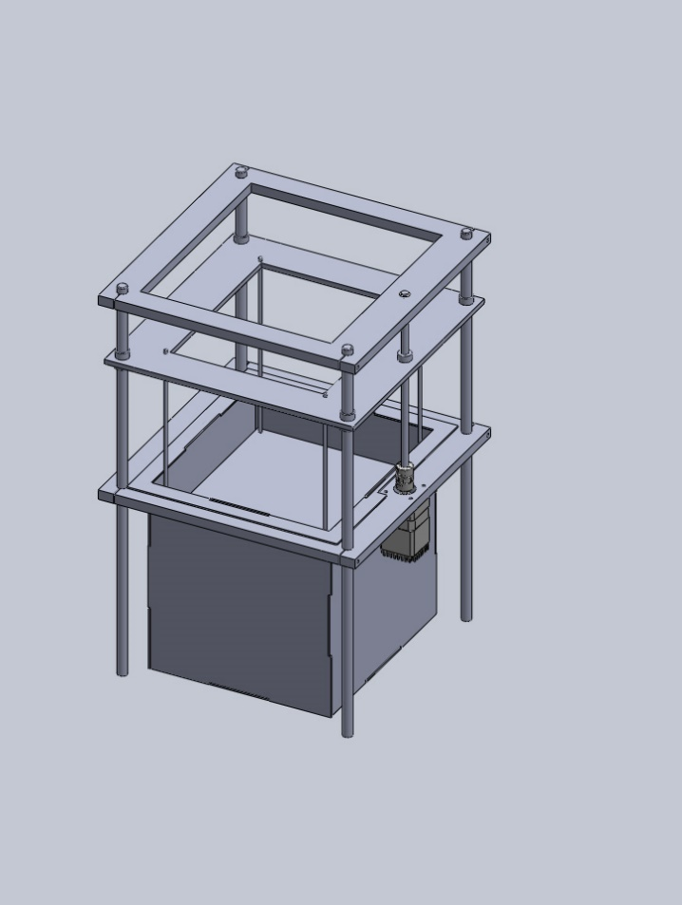

Figure 2: Isometric view of proposed chassis design for Project PAM

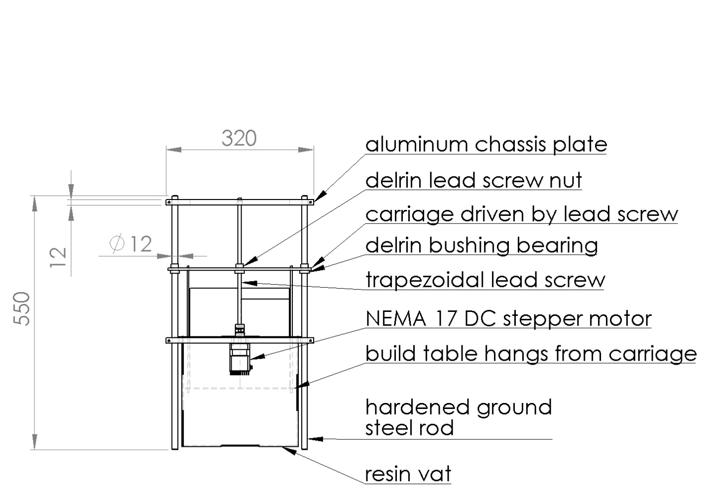

Figure 3: Proposed chassis design for Project PAM

# Print Control Software – DMO

## Introduction

With the recent rise of DLP 3D printing in the hobbyist market there is a need for a more consolidated form of printer control software. Current implantations are very printer specific. There is a need for standard printer control software for all DLP 3D printers. The Creation Workshop by Steve Hernandez is an attempt at a universal 3D printing control software. Table 2 shows the comparison of three open-source printer control software and the proposed software for Project PAM. The only real similarity between the three is that the software is licensed under the GNU General Purpose License, which allows free distribution and modification of the software [19].

## Specifications, Constraints, & Design Considerations

Table 2: Comparison of three open-source printer control software for DLP printers and details of Project PAM’s proposed printer control software

|  |  |  |  |  |
| --- | --- | --- | --- | --- |
|  | B9 Creator | MiiCraft | Creation Workshop | Project PAM |
| Language | C++ [4] | Python [20] | C# [21] | C++ |
| Cross-platform | ✓ [22] | ✗ [23] | ✓ [24] | ✓ |
| Slicing Software | Custom [25] | Skeinforge [20] | Slic3r [21] | Slic3r |
| G-Code Support | ✗ [25] | ✓ [20] | ✓ [21] | ✓ |
| Model File Input | STL [22] | STL [23] | STL, OBJ, 3DS [24] | STL, OBJ, 3DS, STEP, AMF |
| Ability to Add Supports | ✓ [22] | ✗ [23] | ✓ [24] | ✓ |
| Image Output | SLC [25] | SVG [26] | SVG [27] | SVG |

There a few requirements that Project PAM’s printer control software has to meet. Table 3 lists these requirements/features. The system should be able to easily support the resolution of any projector the user has. Having the print control software output layers as W3C scalable vector graphics 1.1 allows the layer image to be scaled to any resolution [28]. The software should support multiple file formats for the CAD files that are imported. The most widely used model format for 3D printing is STL files [29]. In 2011 Additive Manufacturing File Format (AMF) was released, a superset of STL, by the International Organization of Standards (ISO) and American Society for Testing and Materials (ASTM) as ISO/ASTM 52915:2013 [30]. Also, because curves can be better displayed with a PAM system, importing STEP files should also be supported [31]. The slicing software should also output printing instructions as G-Code following ISO 6983-1:2009 [32].

Table 3: Project PAM Printer control software feature list

|  |  |
| --- | --- |
| Feature | Description |
| Layer Images as SVGs | The layers must be outputted as SVG files |
| model file format support | Models of various formats should be supported |
| G-Code Support | The slicing software should generate G-Code instruction |
| Ability to Add Multiple CAD Models | User should be able to add multiple models to the layout to be printed |
| Ability to View Individual Layer Images | User has the ability to view each individual layer image that will be outputted. |
| Resin Catalog | User configurable database of different resins that can be selected at time of print |
| Projector Catalog | User configurable database of different projectors that can be selected at time of print |
| Defaults | User has the ability to set defaults for all settings to allow quicker setup time. |
| Print Projects | Printing settings will be saved for specific prints to allow easier reprints. |

## Discussion

### B9 Creator Software

The B9 Creator is a crowdsourced open-source DLP printer [22] [33]. The B9 Creator’s printer control software is written in C++, using the Qt library for the user interface [25]. It supports STL CAD files as the model input [22], the standard for 3D printing [29]. *Support structure can be manually* added after the import of the STL file [22]. The slicing of each individual layer is done by a custom implementation and outputs SLC files, SLC files are CAD slice files [25]. However, because it uses a custom implementation for slicing there is no standard G-code support.

### MiiCraft Suite

The MiiCraft printer is a DLP printer that has closed-source hardware; however, it has open source printer control software [23]. The MiiCraft’s printer control software, or MiiCraft Suite as it has been dubbed, is written in Python, and uses Tkinter for the user interface [20]. Unlike the B9 Creator and the Creation Workshop the MiiCraft is not cross-platform and only supports Windows [23]. It supports STL CAD files as the model input. The software does not give the user the ability to add supports to the model before printing [23]. Skeinforge is the slicing software used by the MiiCraft [20], which supports the output of each layer as a SVG file through its Vectorwrite plugin [26].

### Creation Workshop

The Creation Workshop is an attempt to provide printer control software for any DLP printer, however it also supports FDM printers [24]. It is written in C#, using OpenTK, which is a C# wrapper for OpenGL, for the user interface [21] [34]. Unlike the B9 Creator and the MiiCraft the Creation Workshop does not only support STL CAD files for the model import, it also supports OBJ and 3DS files [24]. The software does allow supports to be added after the CAD file has been imported. The Creation Workshop uses Slic3r for the slicing software [21], which is written in Perl and supports outputting the layers as SVG files [27]. The Creation Workshop also supports G-code for DLP printers [24].

Of the three open source printer control software evaluated, the Creation Workshop printer is the most powerful. The reason for this is that it uses Slic3r as its slicing engine, which is *the most popular slicing engine* [35]. The other benefit it has over the other two is that it gives the user more freedom than any other printer control software on the market for DLP printers.

## Conclusion

After further investigation into the Creation Workshop it became aperient it was poorly implemented. The idea of Creation Workshop is great, a single piece of software to control all DLP printers; however, that great idea is lost in over complexity and a clunky user interface design. To further complicate modifying the Creation Workshop, none of the team members have experience in C#. Because of these reasons the decision has been made to modify the B9 Creator printer control software. This allows the use C++ according to ISO/IEC 14882:2011 [36]. Of the features listed in Table 2 the B9 Creator’s software has all but the capacity to output layer images as SVGs, the support of multiple model file formats, G-Code support, the projector catalog, and the ability to view individual layer images.

These short comings can be easily alleviated by exchanging the current custom slicing software used by the B9 to Slic3r. This change will add SVG support and G-Code support. The final change that will have to be made is to adapt the Creation Workshop’s support for multiple model file formats and add the capacity to display individual layer images. With those changes to the B9 Creator software all the requirements/features should be met.



Figure 4: Flow diagram for Project PAM printer control software

The flow diagram for Project PAM’s printer control software is shown in Figure 4. The layout software and slicing software will be executed in the printer control software. When a user first opens up Project PAM they will see Figure 5, the Startup Page. In the Startup Page the user will be able to select from a list of recent projects, browse to another project not in this list, or create a new “blank” project. The projects and all associated data will be stored in the W3C standard, Extensible Markup Language (XML) files [37]. Upon the creation of a “blank” project the settings will be set to user definable defaults.

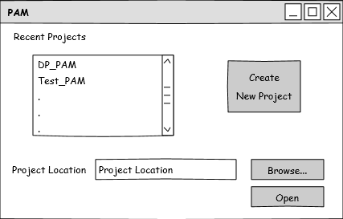

Figure 5: Startup Page of Project PAM Printer Control Software

The first page, after the Startup Page, is the Layout page, Figure 6. In the Layout Page the user will select a pixel size (resolution) and the projector from the projector catalog. Also, the user will be able to edit the projector catalog from this page. The biggest functionality on this page is the user has the ability to add as many models to the layout and manipulate those models within the layout edit window.

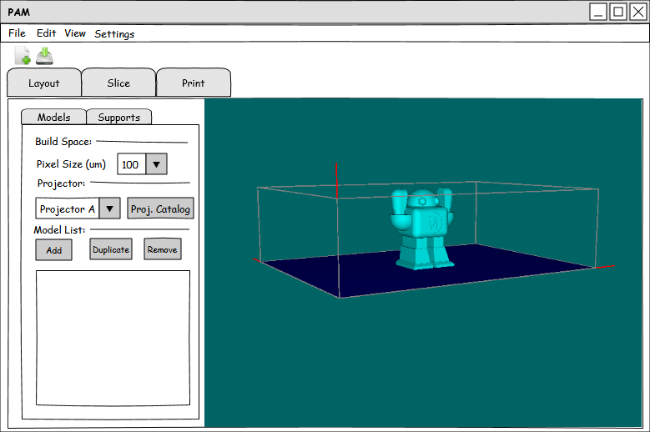

Figure 6: Layout Page of Project PAM Printer Control Software

The next page is the Slice Page, Figure 7. On this page the user sets settings for Slic3r and runs it. After Slic3r is run the user can view and edit the G-Code in a separate text editor window. Also, the user can scroll through all the layer images Slic3r produced.

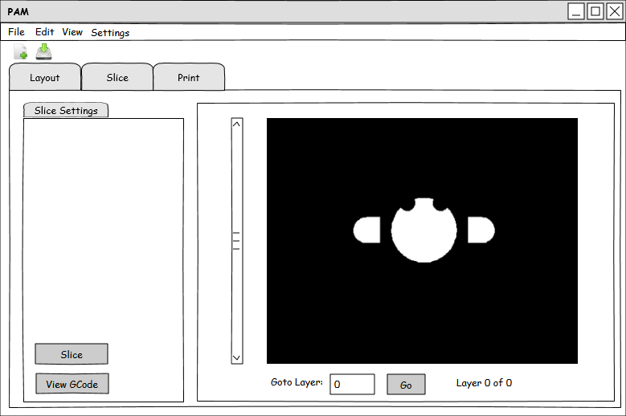

Figure 7: Slice Page of Project PAM Printer Control Software

The final page is the Print Page, Figure 8. On this page the user can “play”, “pause”, and “stop” the print. Before the user can start the print the settings need to be set and there is a checklist that the user has to go through to verify the printer is properly working and configured. The user can also manually type G-Code to be sent to the printer. Also, the user can manually lower and raise the build table with up and down arrows. The final functionality on this page is the display of time remaining and a progress bar showing the current layer.

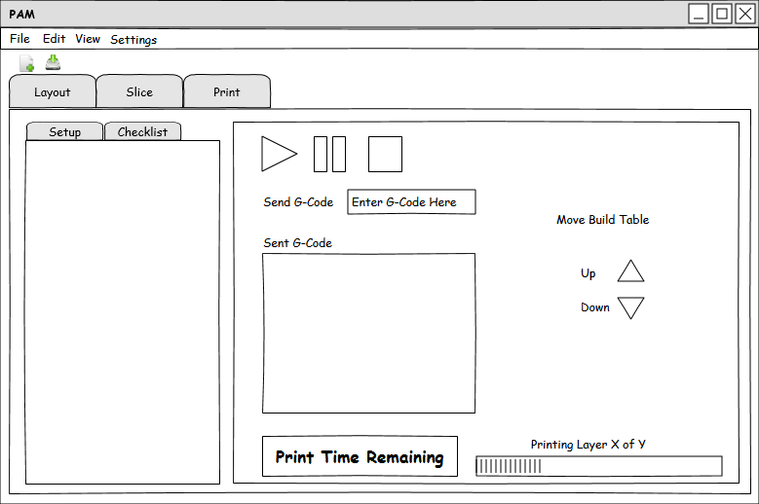

Figure 8: Print Page of Project PAM Printer Control Software

With these modifications to the B9 Creator software the requirements/features in Table 3 will fully be met, and Project PAM will hopefully become the first printer control software to support any PAM system, the most powerful printer control software, and the most open printer control software. This will be done by using Slic3r, *the most popular slicing engine* [35], licensing under the GNU GPL, and maximizing user freedom and control in the software

# Software Hardware Interface – NAL

## Introduction

The control hardware and software both determine the precision of the print. The software breaks down the CAD model into slices and generates a series of steps for the hardware controls.

## Specifications, Constraints, & Design Considerations

The hardware control software should be able to interpret G-code

## Discussion

### Video Output

Digital Light Processing manufacturing uses a projector to cure a liquid resin. The B9 Creator uses the video output from a dedicated host PC to power the projector. The supported video output for the B9 includes VGA and HDMI [22]. The Sedgwick printer supports VGA output only. By using a 1024x768 projector the precision is only slightly hindered by a lower resolution projector [38]. Despite a lower resolution projector than the B9 Creator and Sedgwick can still provide a high quality 3d print.

The EnvisionTEC Perfactory4 printer uses an even higher resolution than the B9 and Sedgwick. Supporting a 1920x1200 resolution, Perfactory4 is extremely precise [39]. The high resolution creates a beautiful print with crisp corners and smooth sides, but at an extremely high cost.

### I/O Support

Input and output support of the microcontroller powers the motors used to drive the build table and send feedback to the software. The B9 Creator is supported by and Arduino controller connected to a dedicated PC via USB [22]. The software running on the PC slices the CAD file and generates a proprietary code to be run on the Arduino. Then the image output from the PC to projector is synced with motion of the build table. The rest of the output is done by the PC. After each layer of the model is processed the video output will send the signal to the projector to display the next layer, allowing the resin to cure.

### G-code

Initially used to control machining tools, G-code is a programming language used to interface the controller and hardware. Instructions from the software produce the G-code, which tells the controller what action to execute. Some actions include setting coordinates, controlled movements, rapid movements, move to origin, trace arcs, and more [40]. This language has been adapted for use with 3d printers and is the standard control instructions.

|  |
| --- |
| G1 F1500  G1 X90.6 Y13.8 E22.4 |

Figure 9: Syntax Example for G-Code

An example of the G-code syntax is shown in Figure 9. This operation instructs the hardware to move to position (90.6, 13.8), extrude resin at a feed rate of 1500mm/minute and extrude 22.4mm of resin [40]. Figure 9 is configured for use with a FDM printer, however it can be adapted for a PAM system with software modifications and produce the same print.

### Controller Firmware

There are several firmware versions for the Arduino which interpret G-code and command motion control hardware. A very popular firmware for the Arduino is Sprinter. The supported features of Sprinter include SD card support, extruder speed control, movement speed control, constant and exponential acceleration, and heated build platforms [41]. It is also compatible with a variety of different Arduino shields, but are only used in FDM systems.

Marlin firmware is forked from Sprinter and has the same functionality and more. The functionality added from Sprinter is support for higher step rates, look ahead (for corners), temperature sampling, and EEPROM error reporting [42]. Like Sprinter many of the additional features only apply to FDM systems, but it still supports PAM systems as well.

# Motion Control – CWS

## Introduction

A stepper motor (or step motor) is a brushless electric motor commonly used manufacturing and robotics. “The rotary motion of a stepper motor can be converted to linear motion using a lead screw/worm gear drive system [43]." This linear motion (whether it be one, two, or three degrees of freedom) is what allows the printers to “print” in 3-Space. What makes a step motor ideal for manufacturing processes such as 3D Printing is the motors ability to rotate a set distance and then hold that position with great accuracy (this corresponds to precision in a given axis). They accomplish this rotation by sending a pulse to a toothed electromagnetic stator, which will turn a gear-shaped rotor until it aligns with the corresponding teeth on the electromagnet. This set rotation from a single pulse is known as a “step”.

## Specifications, Constraints, & Design Considerations

The stepper motor and lead screw together should allow linear motion with a 0.1mm resolution within a precision of 0.005mm. The stepper motor should be able to support the torque produced by the lead screw caused by the weight of the carriage assembly and a print using the maximum dimensions of the build volume.

## Discussion

### Motor Design Characteristics

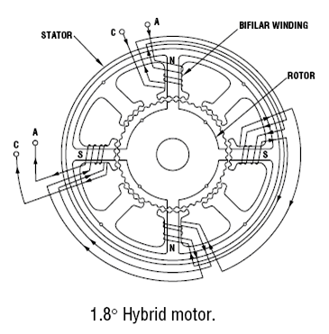

Figure 10: Bipolar Step Motor Diagram [43]

Stepper motors for consumer 3D manufacturing can be separated into two major categories: unipolar and bipolar. These categories refer to the internal winding configuration of the motors.

Bipolar motors have two coils and operate by energizing and reversing the current through a coil winding to achieve stepping as shown in Figure 10. The advantage of this configuration is that it utilizes the entire coil for every step. This enables the motor to produce more torque for a given size [44]. The drawback to this type of configuration is that it requires more complicated drive circuitry [45].

Unipolar motors also implement two coils. However, in this configuration the operator has access to a “center tap” on each coil [44]. This essentially divides each coil in two. Unipolar motors achieve stepping by energizing each section of windings one at a time. The advantage of this configuration is that current direction does not need to be reversed in order to turn the rotor; this allows for simple drive circuitry. The major disadvantage is that, since only half of the coil has current flowing through it at a given time, a unipolar motor cannot produce as much torque as a bipolar motor of the same size [46].

### Step Motor Properties

The three most important motor properties for 3D printer design are step angle, holding torque, and pullout torque.

Step angle is the angle by which the rotor turns when one pulse is applied to the winding coil [47]. Or, more simply, the angle between full steps. This angle is determined by the number of poles and the corresponding number of teeth on the rotor and stator. This rotation then translates to linear motion through the drive system, which means the smaller the step angle, the more precision one has available in the printer itself.

Step angle can also be thought of in terms of the number of steps it takes the motor to turn through 360°, or one full rotation of the rotor. This is often referred to as the step number. For example, a motor with step angle of 3.6° will take 100 steps to complete one full rotation. Either of these parameters may be used to classify step motors.

A step motor will always have a set number of steps. However, it is possible to realize even greater precision through practices known as ‘half-stepping’ and ‘micro-stepping.’ Both methods take advantage of the drive software to attain rotation positions that fall between a full step of the motor. Though, this increase in precision does come at the expense of a decrease in torque; since, once again, there will be less current moving through each coil winding.

Holding torque, according to [48], is “…after step angle – the most important single parameter which is looked for in selecting a motor.” This torque parameter is defined by [49] as “The torque required to deflect the motor from its stable position…” when the motor is at rest and rated current is applied to the windings.

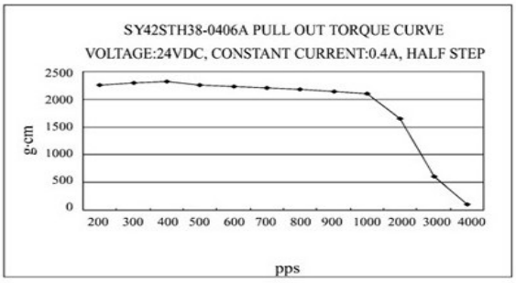

Figure 11: Pull-out Torque with Respect to Velocity [50]

In contrast, pullout torque refers to the maximum torque a motor can supply at a given speed. This inherent characteristic is defined over a wide range of motor speeds and is essentially a limiting factor in performance. When operating at higher speeds the motor cannot supply as much torque to the drive system as shown in Figure 11. This suggests that for a given torque the motor has a limit on how fast it can rotate. Attempting to operate outside of these parameters can cause the motor to misstep and even stall [51].

## Conclusion

Figure 11 shows a graph of pullout torque vs. pulses per second for half-step operation of the step motor project PAM will be implementing. It is a NEMA 17 sized unipolar motor. Speed-torque characteristics are the most important parameters for stepping motors and it is essential to study these characteristics carefully when selecting a motor.

Since the Project PAM printer design will not require stepping through long distances of z-travel, the speed of the motor will not be as critical to the performance of the machine. While the speed may vary slightly depending on specific needs for a particular print the motor should never exceed more than 500 pulses per second. Based on the provided data our printer will be within tolerable ranges for the motors operation. A proposed wiring diagram is shown in Figure 12.



Figure 12: Proposed Wiring for Stepper Motor for Project PAM

# Testing – JPB

## Z-Axis precision

In order to establish the precision of the Z-Axis motion, a mechanical gauge will be fitted by means of a test jig. The carriage will be stepped and deviation from the commanded position will be recorded. If the error is great enough (more than 0.005 mm) a position profile will be programmed which can be referenced by the control software to more accurately step the system.

## Cure time

In order to better establish the curing capabilities of the system testing will be done for resins recording curing time with respect to luminosity of the curing light. This will allow the building of reference tables used by the control software to establish layer cure times for printing.

## Print Accuracy

In order to establish the accuracy of the system a 20 mm cube will be printed and mechanically measured for dimensional accuracy including parallelism and perpendicularity. The printer will be adjusted to provide the most accurate print.

# Project Logistics – DMO

With *Project PAM* the decision was made to bring on two faculty technical advisors (FTA). The first is James Mabry from the Mechanical Engineering Department. He was chosen for his broad educational basis. The second FTA is Joe Lennox. He was chosen for his experience with other 3D printing systems.



Figure 13: Project Organization

*Project PAM* consists of a team of five engineers, organized as shown in Figure 13. The project manager is Jeffery Burdick, a mechanical engineer. He is also in charge of the mechanical motion system and the chassis. Daniel Olsen, a computer engineer, is in charge of the printer control software. Nicholas Lowman, who is also a computer engineer, is in charge of the software-hardware interface. Chance Baker, an electrical engineer, is in charge of resin management and optics. Casey Spencer, who is an electrical engineer, is in charge of motors and motor control. The team meets on Tuesday s at 5:30 P.M. on the 7th floor of Morris Library and on Thursday s at 12:15 P.M. in Engineering A207.

Table 4: Action Item List

|  |  |  |
| --- | --- | --- |
| Task Name | Due Date | Personnel Assigned |
| **Build Phase** | **2014-09-26** |  |
| Order Parts | 2014-08-22 | CWS,NAL |
| Linear Motion Assembly | 2014-09-14 | JPB,CWS,NAL |
| Test Liner Motion System | 2014-09-22 | JPB,CWS,NAL |
| Resin Tests | 2014-08-22 | CWB |
| Vat Assembly | 2014-09-05 | CWB |
| Chassis Assembly | 2014-09-05 | JPB |
| Printer Control Software | 2014-09-26 | DMO |
| Projector/Optics Assembly | 2014-09-19 | CWB,JPB |
| Test Photoresin Cure with Projector | 2014-09-22 | CWB,JPB |
| System Assembly | 2014-09-26 | TEAM |
| **Testing Phase** | **2014-11-07** |  |
| First System Test | 2014-10-03 | TEAM |
| Troubleshooting/Debugging | 2014-11-07 | TEAM |
| **Presentation Phase** | **2014-12-12** |  |
| Write Report | 2014-11-28 | TEAM |
| Documentation | 2014-11-28 | TEAM |
| Demonstration | 2014-12-05 | TEAM |
| Posters | 2014-12-05 | TEAM |
| Presentation | 2014-12-12 | TEAM |

The project will be accomplished in three phases as shown in Table 4; the build phase, testing phase, and the presentation phase. The build phase will last for the first 30 days of the project. All assembly and early subsystem testing will happen during this phase. The next 30 days will be devoted to testing. The first system test will happen during the first week of this phase. Followed by three weeks of troubleshooting and debugging. The final phase is the presentation phase, which will last for 25 days. During this phase all documentation, presentation, and reports will be developed within the first 15 days of the phase. The final two weeks of the project are devoted to demonstrations and presentations.

Table 5: Budget

|  |  |  |
| --- | --- | --- |
| Item | Total Price | Department Acquisition (Y/N) |
| **Arduino Uno** | $38.00 | Y |
| **Enclosure** | $86.24 | N |
| **Aluminum plate for chassis and build table** | $148.00 | N |
| **12mm ground linear bearing rod 1500mm** | $93.70 | Y |
| **Chassis hardware** | $37.00 | Y |
| **Photoresin vat** | $47.00 | N |
| **Makerjuice resins** | $47.00 | N |
| **Motion control system** | $112.00 | Y |
| **DLP projector** | $344.00 | N |
| **Computer** | $0.00 | Y |
| **TOTAL** | $952.94 |  |

The goal for the budget was to not exceed $1000, without including the cost of the projectors. The team has successfully done this. The total for the budget shown in Table 5 is $953, which is under the $1000 goal.

# Conclusion – JPB

Team 75 is in a great position to be able to make a large and important contribution to the open source community by filling a need and providing a service. This would allow the design project to contribute not just to the educations of the project members, or the resources of the school. The project will allow a foundation for the maker community to build upon and provide a lasting legacy for the project members and the school. At the conclusion of the project the Saluki Makerspace will have a fast, accurate, and fault-tolerant printer.

# References

|  |  |
| --- | --- |
| [1] | "3D Printing: What You Need to Know," [Online]. Available: http://www.pcmag.com/slideshow_viewer/0,3253,l=293816&a=289174&po=1,00.asp. [Accessed 17 April 2014]. |
| [2] | "3D Printing Scales Up," *The Economist,* 7 September 2013. |
| [3] | F. L. J. L. a. J. F. IM. Tehfe, "Photopolymerization Reactions: ON the Way to a Green and Sustainable Chemistry 1ed., from Institut de Science des Materiqux de Mulhouse," 28 March 2013. [Online]. |
| [4] | "Getting Started, "B9 Creator"," January 2013. [Online]. Available: b9creator.com. [Accessed 23 February 2014]. |
| [5] | "I3XL-PRUSA I3 9X12X7, "DIY Techshop," [online]," January 2014. [Online]. Available: shop.diytechshop.com. [Accessed 20 February 2014]. |
| [6] | "Print Not Sticking to Build Plate, "Build Your Own SLA"," January 2014. [Online]. Available: www.buildyourownsla.com. [Accessed 26 February 2014]. |
| [7] | MakerBot, "MakerBot Fifth Generation Replicator Series Desktop 3D Printers," MakerBot, [Online]. Available: http://store.makerbot.com/fifth-generation-replicators. [Accessed 27 February 2014]. |
| [8] | Formlabs, "The Form 1 3D Printer," 2013. [Online]. Available: http://formlabs.com/products/our-printer. [Accessed 27 February 2014]. |
| [9] | Free Sotfware Foundation, "Philosophy of the GNU project," 26 November 2013. [Online]. Available: http://www.gnu.org/philosophy/philosophy.html. [Accessed 27 February 2014]. |
| [10] | OpenBeam USA, "Blog," [Online]. Available: http://www.openbeamusa.com/. [Accessed 27 February 2014]. |
| [11] | MakerBeam.eu, [Online]. Available: http://www.makerbeam.eu/. [Accessed 27 February 2014]. |
| [12] | OpenBuilds, "OpenBuilds Parts Store V-Slot," 2014. [Online]. Available: http://openbuildspartstore.com/v-slot/. [Accessed 27 February 2014]. |
| [13] | OpenBuilds, "OpenBuilds Parts Store OpenRail," 2014. [Online]. Available: http://openbuildspartstore.com/openrail/. [Accessed 27 February 2014]. |
| [14] | LulzBot, "TAZ 3D Printer," [Online]. Available: https://www.lulzbot.com/?q=products/taz-3d-printer. [Accessed 27 February 2014]. |
| [15] | Ultimaker BV, "Ultimaker 2," 2014. [Online]. Available: https://www.ultimaker.com/pages/our-printers/ultimaker-2. [Accessed 27 February 2014]. |
| [16] | International Organization for Standardization, "ISO 262:1998," 11 April 2014. [Online]. Available: http://www.iso.org/iso/iso_catalogue/catalogue_tc/catalogue_detail.htm?csnumber=4167. [Accessed 11 April 2014]. |
| [17] | Printrbot, "Printrbot Kits," 2014. [Online]. Available: http://printrbot.com/product-category/printrbot-kits/. [Accessed 27 February 2014]. |
| [18] | Deezmaker, "Bukito Portable 3D Printer," 2014. [Online]. Available: http://deezmaker.com/bukito-portable-3d-printer/. [Accessed 27 February 2014]. |
| [19] | Free Software Foundation, "GNU.org," 29 June 2007. [Online]. Available: https://www.gnu.org/copyleft/gpl.html. [Accessed 17 April 2014]. |
| [20] | MiiCraft, "MiiCraft Suite GitHub," GitHub Inc., 2014. [Online]. Available: https://github.com/miicraft/MiiCraftSuite. [Accessed 27 February 2014]. |
| [21] | S. Hernandez, "Creation Workshop GitHub," GitHub Inc., 2014. [Online]. Available: https://github.com/Pacmanfan/UVDLPSlicerController. [Accessed 27 February 2014]. |
| [22] | E. Chu, "B9 Creator," *Make: Ultimate Guide to 3D Printing,* p. 93. |
| [23] | Rays Optics Inc., "MiiCraft User Guide," 2012. [Online]. Available: http://www.miicraft.com/web/assets/2012/11/MiiCraft-3D-printer-User-Guide.pdf. [Accessed 27 February 2014]. |
| [24] | S. Hernandez, "Creation Workshop - SLA / FDM Slicer and Controller," Makerbot Industries LLC, 8 January 2013. [Online]. Available: https://www.thingiverse.com/thing:40778. [Accessed 27 February 2014]. |
| [25] | B9 Creations LLC, "B9 Creator GitHub," GitHub Inc., 2014. [Online]. Available: https://github.com/B9Creations/B9Creator. [Accessed 27 February 2014]. |
| [26] | Fabmetheus, "Skeinforge Vectorwrite," Demozendium, 17 July 2012. [Online]. Available: http://fabmetheus.crsndoo.com/wiki/index.php/Skeinforge_Vectorwrite. [Accessed 27 Febuary 2014]. |
| [27] | A. Ranellucci, "Slic3r Manual," GitHub Inc., 2014. [Online]. Available: https://github.com/alexrj/Slic3r-Manual. [Accessed 27 February 2014]. |
| [28] | W3C, "Scalable Vector Graphics (SVG) 1.1 (Second Edition)," 16 August 2011. [Online]. Available: http://www.w3.org/TR/SVG/. [Accessed 16 April 2014]. |
| [29] | S. Ragan, "Software for 3D Printing," *Make: Ultimate Guide to 3D Printing,* pp. 34-35. |
| [30] | ISO/ASTM 52915:2013, *Standard specification for additive manufacturing file format (AMF) Version 1.1.* |
| [31] | ISO 10303-21:2002, *Industrial automation systems and integration -- Product data representation and exchange -- Part 21: Implementation methods: Clear text encoding of the exchange structure.* |
| [32] | ISO 6983-1:2009, *Automation systems and integration -- Numerical control of machines -- Program format and definitions of address words -- Part 1: Data format for positioning, line motion and contouring control systems.* |
| [33] | "B9 Creator," B9 Creations LLC, 2013. [Online]. Available: http://b9creator.com/. [Accessed 27 February 2014]. |
| [34] | S. Apostolopoulos, "OpenTK," Stefanos A. Icons, 2013. [Online]. Available: http://www.opentk.com/. [Accessed 17 April 2014]. |
| [35] | J. Abella, "Slicing and Control Software: Where it's going and where it's been," *Make: Ultimate Guide to 3D Printing,* p. 90. |
| [36] | ISO/IEC 14882:2011, *Information technology -- Programming languages -- C++.* |
| [37] | W3C, "XML 1.1 Extensible Markup Language (XML) 1.1 (Second Edition)," 16 August 2006. [Online]. Available: http://www.w3.org/TR/2006/REC-xml11-20060816/. [Accessed 16 April 2014]. |
| [38] | "Sedgwick 3D DLP Printer ready to print," 2014. [Online]. Available: http://sedgwick3d.com/p/9/sedgwick-3d-dlp-printer-ready-to-print. [Accessed 16 April 2014]. |
| [39] | "Perfactory 4 with ERM," 2014. [Online]. Available: http://envisiontec.com/products/perfactory-4-standard-with-. [Accessed 15 April 2014]. |
| [40] | "G-code RepRap," 2014. [Online]. Available: http://reprap.org/wiki/G-code#Unbuffered_M_and_T_commands. [Accessed 17 April 2014]. |
| [41] | "Sprinter," [Online]. Available: http://reprap.org/wiki/Sprinter. [Accessed 17 April 2014]. |
| [42] | "Marilin," 2014. [Online]. Available: http://reprap.org/wiki/Marlin. [Accessed 17 April 2014]. |
| [43] | O. E. Co, "Introduction to Stepper Motors," Omega, [Online]. Available: http://www.omega.com/prodinfo/stepper_motors.html. [Accessed 26 February 2014]. |
| [44] | J. D. Wale and C. Pollock, "Hybrid Stepping Motors and Drives," *Power Engineering Journal,* pp. 5-12, 2001. |
| [45] | R. Condit and D. Jones, "Stepping Motors Fundamentals," [Online]. Available: http://www.bristolwatch.com/pdf/stepper.pdf. [Accessed 27 February 2014]. |
| [46] | "Rep RAp Wiki," Rep Rap, [Online]. Available: http://reprap.org/wiki/Stepper_motor. [Accessed 25 February 2014]. |
| [47] | Subrahmanyam, Electronic Drives: Concepts and Applications, Tata McGraw-Hill, 2011. |
| [48] | A. Hughes, Electronic Mortors and Drives: Fundamentals, Types, and Applications, Waltham: Elsevier Ltd., 2013. |
| [49] | J. F. Gieras, Permanent Magnet Motor Technology: Design and Applications, Marcel Dekker, Inc, 2002. |
| [50] | "Robot Shop," [Online]. Available: http://www.robotshop.com/media/files/pdf/rb-soy-03-unipolar-stepper-motor-specs.pdf. [Accessed 11 March 2014]. |
| [51] | "Products: Stepper Motors," Oriental Motors, [Online]. Available: http://www.orientalmotor.com/technology/articles/article-speed-torque-curves-for-step-motors.html. [Accessed 28 February 2014]. |

# Appendix